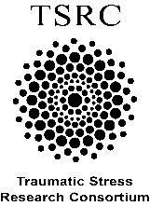
SCORING FOR PURPOSE IN LIFE SCALE (ALL FORMS)

- PURPOSE IN LIFE SHORT SCALE SCORING (6 ITEMS)

For items 1-5, assign numbers to the response options so that:

Strongly disagree = 1
Somewhat disagree = 2
Neither agree nor disagree = 3
Somewhat agree = 4
Strongly agree = 5

For item 6, reverse this scoring

Once recoded into numbers, the average (mean) score which will measure purpose in life on a scale of 1 (low purpose) to 5 (high purpose).

- PURPOSE IN LIFE ORIGINAL SCALE SCORING (12 ITEMS)

For items 1-2 and 4-11, assign numbers to the response options so that:

Strongly disagree = 1
Somewhat disagree = 2
Neither agree nor disagree = 3
Somewhat agree = 4
Strongly agree = 5

For item 3 and 12, reverse this scoring

Once recoded into numbers, the average (mean) score which will measure purpose in life on a scale of 1 (low purpose) to 5 (high purpose).

